- US equity prices fell for four consecutive days—but are set to open higher today (link)
- US corporate treasurers become bondholder-friendlier amid ‘higher for longer’ (link)
- Large banks attempt to serve as matchmakers for private credit deals (link)
- Analysts no longer see Bank of England rate cut in May (link)
- Colombia's local currency bonds sell off as pension reform is discussed (link)
- Nigeria further tightens monetary policy by reducing loan-to-deposit ratio (link)
Mature Markets | Emerging Markets | Market Tables

Markets Set to Break Losing Streak
After four consecutive days of declines for the S&P 500 index, futures prices now point to a higher opening (+0.2%). Concerns about geopolitical risks continue to linger, but oil prices declined yesterday and today, and similarly, the US dollar rally also came to a halt. Yesterday, the technology sector led losses among US stocks after Dutch chip-machine-maker ASML came with disappointing earnings. This sparked concern about the sustainability of this year’s rally in US technology stocks, and in particular those in the semiconductor value chain. On Thursday however, chipmaker TSMC came with better-than-expected results, improving sentiment. Next week, six out of the “Magnificent Seven” firms will present their earnings. Overall, global equities advanced moderately today. European sovereign yields were stable, and US Treasury yields edged up marginally this morning after initial jobless claims came in slightly lower than expected. The 2-year Treasury yield declined by 5 bps yesterday, but at 4.93% it remains 67 bps higher than at the start of 2024, and the “higher for longer” narrative remains an important theme in markets. Yesterday, the Fed said in its Beige Book that firms reported greater difficulty in passing on higher costs.

Mature Markets back to top
United States
Wednesday marked the fourth day in an S&P 500 losing streak. Despite yesterday's Treasury market rally offsetting Tuesday's long-term rate increases, higher rates alongside lingering geopolitical tensions remain the central trading themes. The market-implied distribution of policy rate outcomes has shifted rightwards relative to two months ago, reflecting an upward shift in the path of expected policy rates given strong growth and the risk that inflation will remain hot. Option implied volatility was marginally lower Wednesday across asset classes but still elevated. Analysts argue that there are similarities between the current situation and last summer's when the 2-year Treasury yield consolidated at around 5%. After the summer of last year, higher yields triggered fears of an eventual hard landing, and equity markets saw a correction of about 10% in the following months.
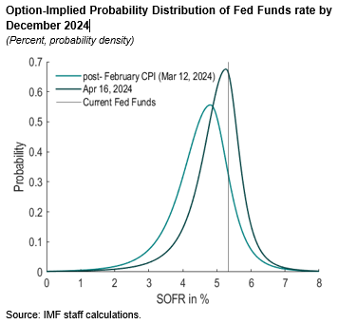
Large US banks reportedly attempt to serve as matchmakers for private credit deals. According to Bloomberg, private lenders have increasingly taken more territory when it comes to loans to riskier firms, leading banks to consider other ways to get involved in this lucrative and growing area. To reclaim the business their leveraged lending desks have lost, banks reportedly provide matchmaking services on recent transactions between smaller companies looking for loans and private lenders eager to provide financing, where large banks can leverage their broad network of corporate clients for a fee, according to Bloomberg.
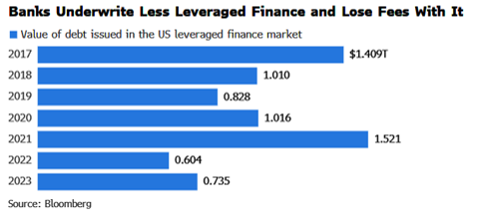
'Higher for longer' makes corporates more conservative in managing their capital. Non-financial corporations built up a record cash buffer during the Covid pandemic, partly thanks to unprecedented policy support. The buffer has unwound since then, leaving cash balances near historical averages. According to GS analysts, in 2021 and 2022, the key themes for corporates' cash spending were shareholder-friendly: M&A, dividends, and share buybacks. However, the fiscal year 2023 was different: In both investment grade and high yield, boards have increased their bondholder-friendly spending, with capex and long-term debt reduction increasing year-over-year as a percentage of total spending, while dividends/stock buybacks and M&A decreased. This shift in spending may signal a focus more on "weathering the storm" with stability front and center rather than prioritizing inorganic growth and paying shareholders. Analysts see that a higher-for-longer environment creates stronger incentives for firms to manage capital conservatively.
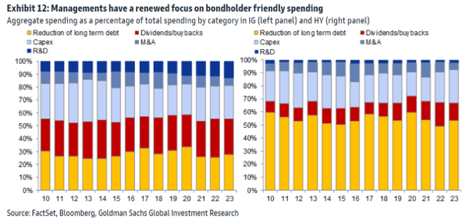
Euro Area
European equities were mostly trading in the green this morning with the STOXX 600 index 0.1% higher. Most sectors gained, with the banking sector up 0.8%, while the energy sector (-1.1%) underperformed. Euro area sovereign yields traded sideways, after declines yesterday. Contacts noted that yesterday’s moves were helped by the decline in oil and gas prices. Commerzbank analysts also highlight that the 10y bund yields is finding support below 2.5% with encouraging UST price action and also ECB commentary that continue to lean dovish. The euro was little changed against the dollar trading at around 1.0672. ING analysts expect the euro to struggle to sustain a move above 1.07.
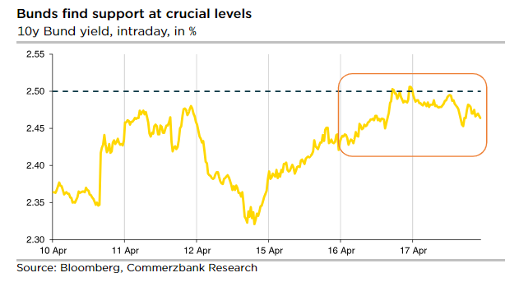
ECB commentary continues to be perceived as leaning to the dovish side. Yesterday, ECB Governing Council (GC) member Centeno commented that it is about time to “change this monetary policy”, while two representatives seen to be in the hawkish camp, GC members Nagel and Holzmann, also spoke in favor of interest rate cuts. Holzmann, however, said that he is not yet fully convinced that the easing cycle should start in June pointing to higher oil prices and wages as risk factors. Overall, contacts note that the ECB appears to be moving ever closer to cutting interest rates in the near future. Despite the geopolitical risks, markets remain almost certain about a 25bps cut in June with roughly 22bps of easing priced in, and continue to price in about 80bps of ECB rate cuts in 2024. In the meantime ECB Board member Schnabel commented that the ECB should reconsider how it forecasts growth and inflation.
United Kingdom
Analysts no longer expect a rate cut in May. Taking into consideration the revised more hawkish expected path for US rates, UK data releases this week showing less softening than anticipated, and also higher implied uncertainty against a backdrop of geopolitical tensions, analysts have changed their calls and see Bank of England (BoE) rate cuts starting later. Morgan Stanley, for example, now expects the first rate cut in June (as opposed to May) and Deutsche Bank analysts have also pushed out BoE rate cut expectations from May to June. Both still expect 75bps of total rate cuts in 2024. In the meantime, the pound softened yesterday in later trading following dovish remarks from BoE Governor Bailey, who noted that the UK and Europe are facing less of an inflation threat than the US. Implied market pricing deviates from above-mentioned analyst expectations, with roughly 45bps of BoE rate cuts priced for 2024, compared to 56bps priced in at the end of last week, and the first rate cut fully priced by September. ING analysts expect market pricing for BoE rate cuts to increase in the coming months, which in turn could weigh on the pound. The pound was trading stronger against the dollar this morning (+0.2% at around 1.2474) and 10y gilts yields were marginally lower (-4bps to 4.22%).
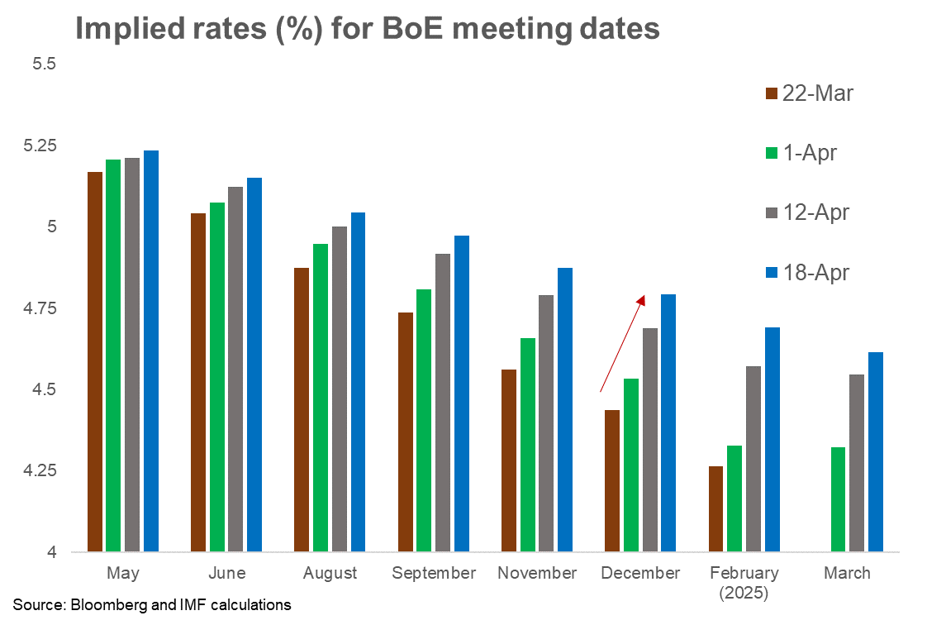
Japan
The G7 group reportedly reaffirmed its view that disorderly FX moves can have adverse implications for macro-financial stability. Analysts suggested that such an acknowledgement gives a tacit permission for Japan to intervene to reduce currency volatility. Separately, US Treasury Secretary Yellen reportedly acknowledged concerns of Japan and Korea over their sharp exchange rate depreciation. Today, Japanese yen was little changed at around 154.4 yen per dollar. Japanese equities gained (NIKKEI: +0.3%), similar to regional trends. Long-end Japanese government bond yields dropped (10-year: -1.4 bps; 30-year -2.1 bps), following Wednesday’s decline in US treasury yields.

Emerging Markets back to top
EMEA equities were mostly weaker today, as well as currencies. Stock markets saw losses in CEE, in particular in Hungary (-0.5%), and traded laterally in South Africa, gaining however (+0.2%) in Türkiye. CEE currencies were weaker against the euro, save for the Polish zloty, which marginally appreciated (+0.1%), trading at 4.33/€ and where the 10y government bond yield spread against the Bund fell by 6bps to 326.7bps from 332.5bps yesterday. In Türkiye the lira kept being weak (-0.1%) against the dollar, trading at 32.51/$. In South African the rand was stable against the dollar, trading at 19.03/$. Elsewhere, the Central Bank of Nigeria reduced banks’ loan-to-deposit ratio to 50%, from 65%, to curb liquidity and tame inflationary pressures.
Asian markets advanced today on improving global risk sentiment. Asian equities gained, up 1.2% on net, led by Koran (+2.0%), Singaporean (+1.0%) and Hong Kong (+0.8%) stocks. Asian currencies also appreciated, led by Korean won (+1.0%), Taiwan dollar (+0.3%) and Indonesian rupiah (+0.3%) amid a broad-based weakening of USD. Long-end government bond yields declined, with 10-year yields falling in Korea (-6.0 bps), Thailand (-5.2 bps) and Taiwan Province of China (-4.5 bps). In Hong Kong SAR, the unemployment rate edged up to 3.0% in March.
Latin American assets performed mixed. Stocks declined in Mexico (-0.7%) and Colombia (-1.3%) while Chile’s equity market rose by 0.4%. Currencies appreciated in Brazil (0.8%), Mexico (0.6%), Colombia (0.4%) and Chile (0.4%) against the US dollar. Brazil’s economic activity index rose 0.4% in February.
China
The People’s Bank of China (PBoC) reiterated the need to prevent one-sided moves in the renminbi. On its social media account, the PBoC reportedly said that China will resolutely put the renminbi back on track when traders place lopsided bets and will avoid excessive currency volatility. Separately, Zhu Hexin, the head of the State Administration of Foreign Exchange and PBC deputy governor, said that China is capable of maintaining a stable FX market and that improving economic conditions will support RMB. The PBoC set the daily RMB fixing slightly stronger today than yesterday, while the deviation from market consensus remained wide at 1,279 pips. RMB was little changed at 7.24 yuan per dollar. CGB yields declined (1-year: -0.9 bp; 10-year: -0.8 bp). Chinese equities gained (CSI 300: +0.1%; Hong Kong SAR-listed: +0.9%), similar to regional trends. While overall market sentiment remained weak, dividend stocks have surged notably this year. In particular, Shanghai Stock Exchange Dividend Index, which largely capture energy firms and banks, has increased by 20% YTD, hitting the highest level since mid-2015. Analysts warned that this hottest trade is reaching a bubble level. Investors started chasing dividend plays amid a low interest rate environment and a stock market rout in early 2024. Recent policy guideline to boost dividend payment further fueled the rally.
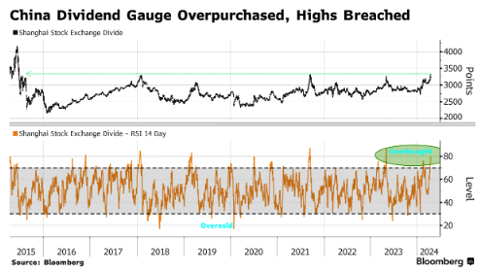
Colombia
Colombia's local currency bond prices sank to their lowest level in five months, as investors fear that the pension system reform could reduce demand for local debt. The peso-denominated 10-year bond yield surged by 23 basis points to 11.3%, the highest level since November. The Finance Ministry projects that this reform could empower the government to manage approximately 70% of total worker pension contributions. Economists suggested that pension funds might refrain from participating in local bond auctions until they gain more clarity on the money they manage. Colombia’s pension funds currently hold 30% of Colombia's 516 trillion peso ($132 billion USD) local currency debt.
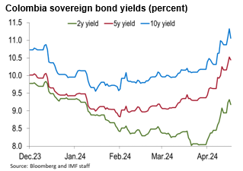
Nigeria
The Central Bank of Nigeria cut banks’ loan-to-deposit ratio to 50%, (previous 65%) in an effort to reduce liquidity and harness inflation (31.7%y/y in March). The move comes after the central bank increased the minimum reserve requirement for banks to 45% from 32.5% in February and raised the benchmark interest rate by 600 basis points to 24.75% between February and March. After losing 44% of its value against the dollar form the begging of the year until mid-March, the naira has partially recovered, but is still roughly 22% weaker than at the start of the year.
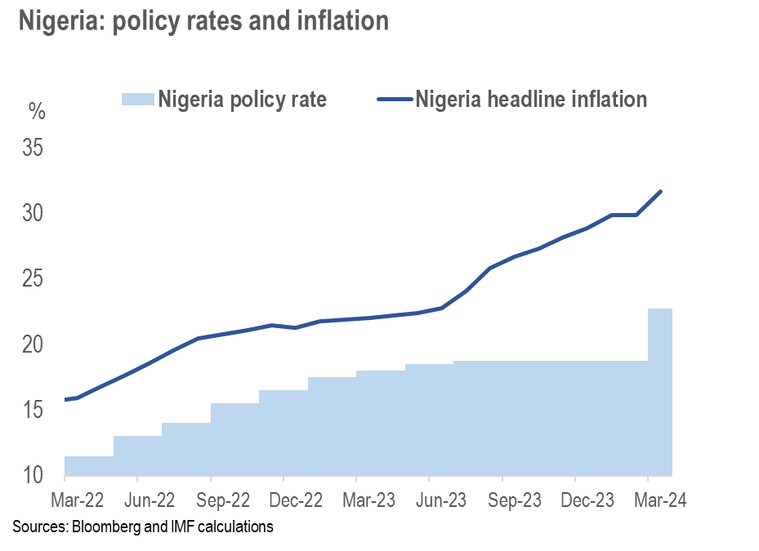
This monitor is prepared under the guidance of Jason Wu (Assistant Director), Charles Cohen (Advisor), Nassira Abbas (Deputy Division Chief), Caio Ferreira (Deputy Division Chief) and Sheheryar Malik (Deputy Division Chief). Fabio Cortes (Senior Economist), Sanjay Hazarika (Senior Financial Sector Expert), Esti Kemp (Financial Sector Expert-London Representative), Johannes S Kramer (Senior Financial Sector Expert-New York Representative), Benjamin Mosk (Senior Financial Sector Expert), Patrick Schneider (Financial Sector Expert), and Jeff Williams (Senior Financial Sector Expert) are the lead editors of this monitor. The contributors are Mustafa Oguz Caylan (Research Officer), Yingyuan Chen (Financial Sector Expert), Andrew Ferrante (Research Assistant), Deepali Gautam (Senior Research Officer), Phakawa Jeasakul (IMF Resident Representative in Hong Kong SAR), Harrison Kraus (Research Assistant), Yiran Li (Research Assistant), Xiang-Li Lim (Financial Sector Expert), Corrado Macchiarelli (Economist), Kleopatra Nikolaou (Senior Financial Sector Expert), Natalia Novikova (IMF Resident Representative in Singapore), Sonal Patel (Senior Financial Sector Expert-London Representative), Silvia Ramirez (Senior Financial Sector Expert), Ying Xu (Economist), Dmitry Yakovlev (Senior Research Officer), and Akihiko Yokoyama (Senior Financial Sector Expert). Javier Chang (Senior Administrative Coordinator), Lauren Kao (Administrative Coordinator), and Srujana Sammeta (Administrative Coordinator) are responsible for the word processing and production of this monitor.
Disclaimer: This is an internal document produced by the Global Markets Analysis Division (GA) of the Monetary and Capital Markets Department. It reflects GA staff’s interpretation and analysis of market views and developments. Market views presented may or may not reflect a consensus of market participants. GA staff do not independently verify the accuracy of all data and events presented in this document.

Global Financial Indicators

Emerging Market Financial Indicators
back to top

